**Experiment No. 07**

* 1. **Experiment Name**

8255 PPI interfacing: 7 - segment display

* 1. **Objectives**
* To get acquainted with the "MDA 8086" Trainer Board and its operation
* To learn how to implement program in “MDA 8086” Trainer Board and interconnect it with “Emu 8086”
  1. **Theory**

A serial monitor mode is one of the configurations of 8086 MDA kit. Here, the monitor starts working as soon as the power is turned on. The program code should be written in Notepad and saved as an ASM file, which is transformed to OBJ files. Using the 'Comm' software, the code is then loaded into the MDA 8086 trainer kit.

For this experiment, we applied 8255 interfacing in 7 – segment decoder. Here, the LED, has seven segments, is used as a highly frequent output device. Furthermore, we have eight segments in an LED display, which contains '.', which is character 8 with a decimal point, dp directly next to it. The segments are denoted as 'a, b, c, d, e, f, g, and dp.' Furthermore, these are LEDs, or a series of Light Emitting Diodes.

* 1. **Apparatus**
* MDA 8086 - Trainer Board
  1. **Experimental problem no. 01**

**CODE SEGMENT**

**ASSUME CS: CODE, DS: CODE, SS: CODE, ES: CODE**

**ORG 1000H**

**PORTA EQU 19H**

**CONTRL EQU 1FH**

**MOV AL, 100000000B**

**OUT CONTRL, AL**

**MOV AL, 100000000B**

**OUT PORTA, AL**

**CODE ENDS**

**END**

* 1. **Output procedures**

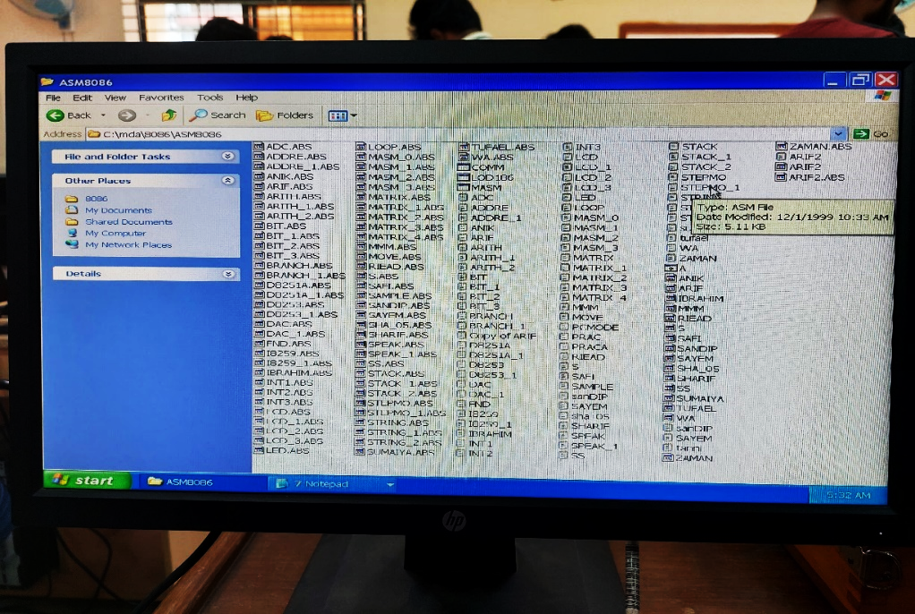

Fig. 7.1: Opening file directory

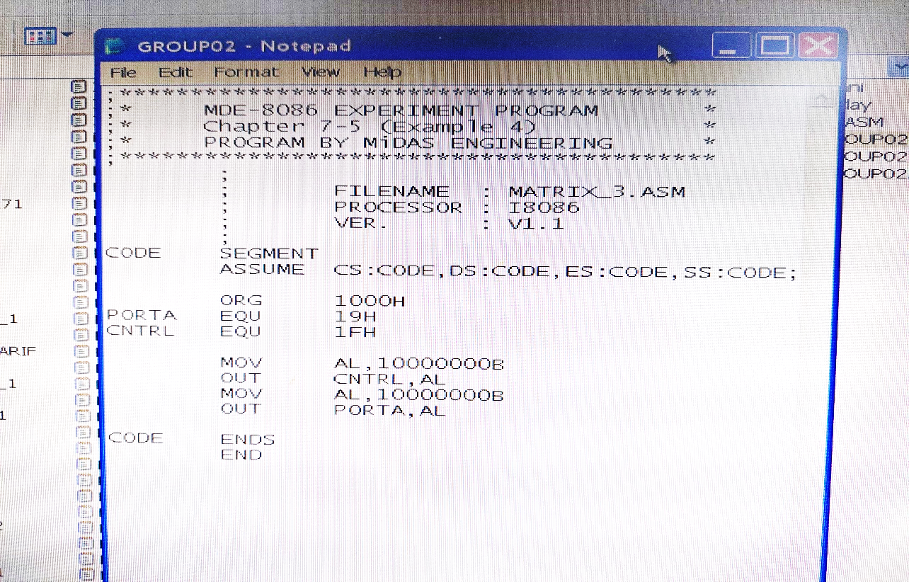

Fig. 7.2: Writing program on notepad

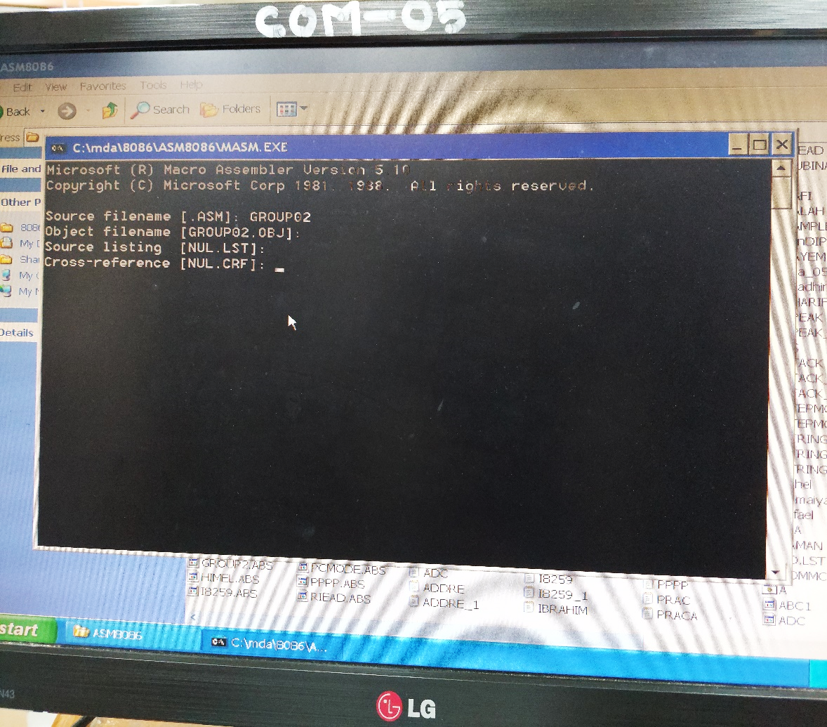

Fig. 7.3: Load the ‘.asm’ file and convert it to ‘.obj’ file format.

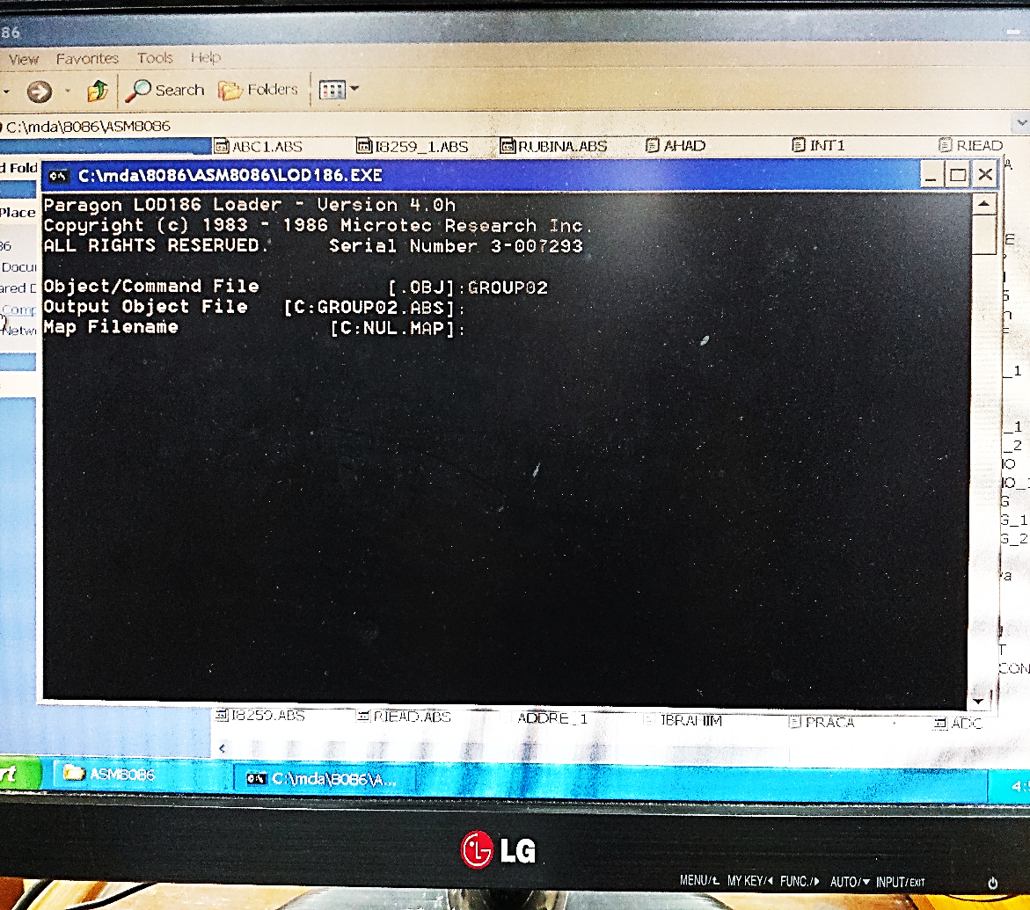

Fig. 7.4: Turn ‘.obj’ file to ‘.abs’ file

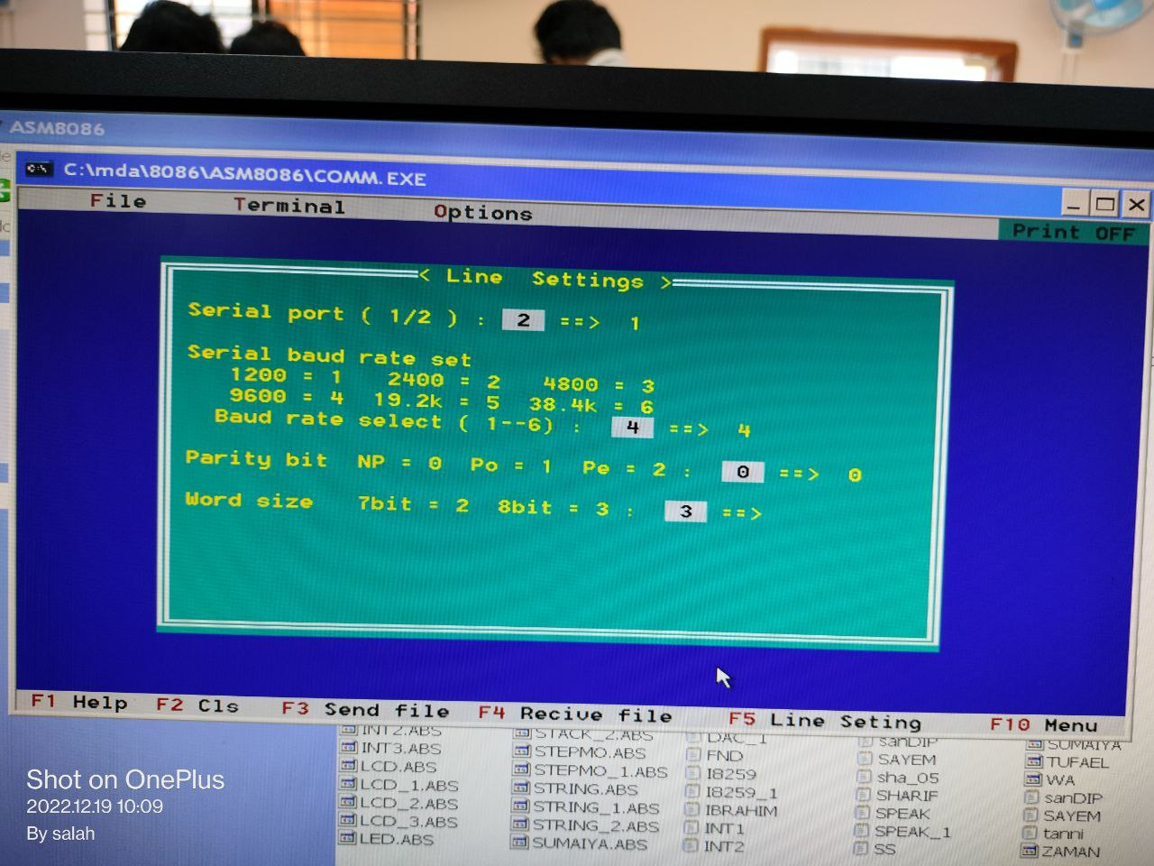

Fig. 7.5: Select serial port

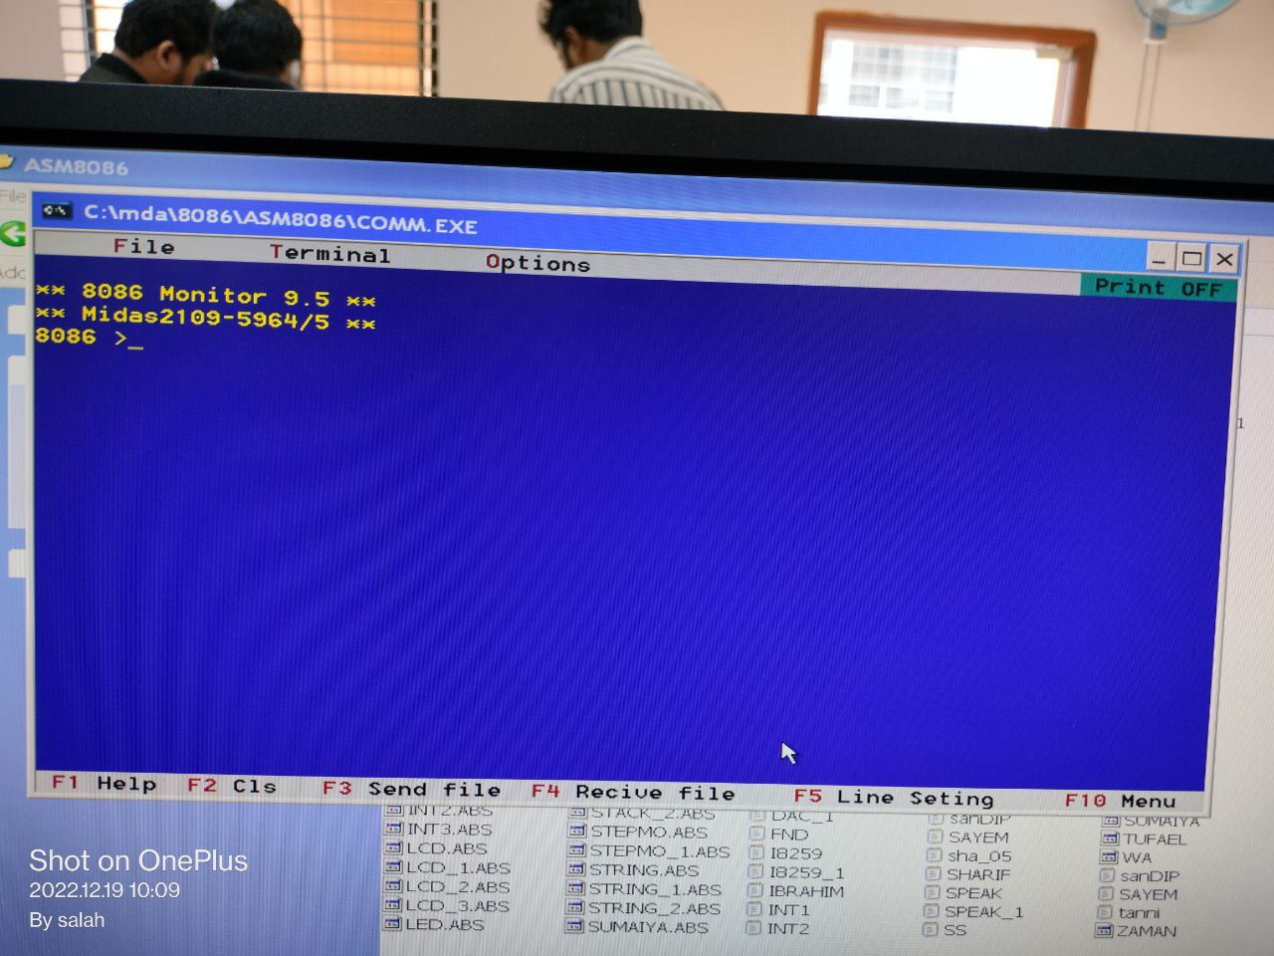

Fig. 7.6: Reset the kit

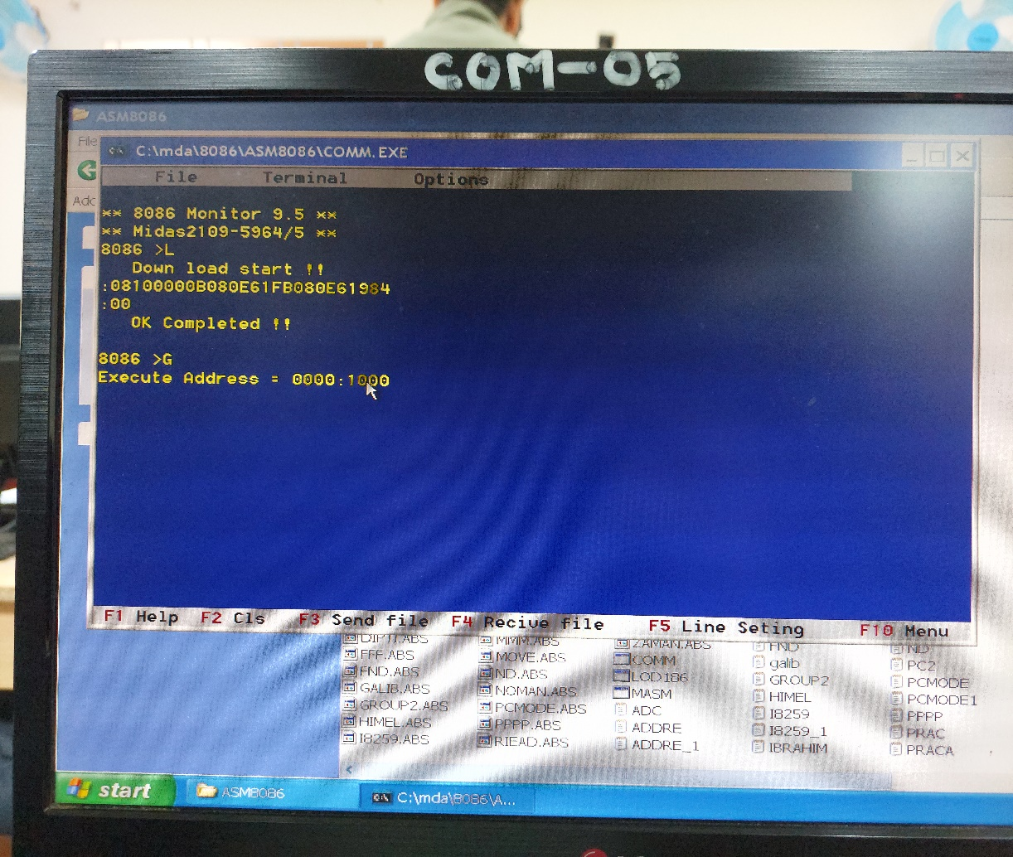

Fig. 7.8: Load the file

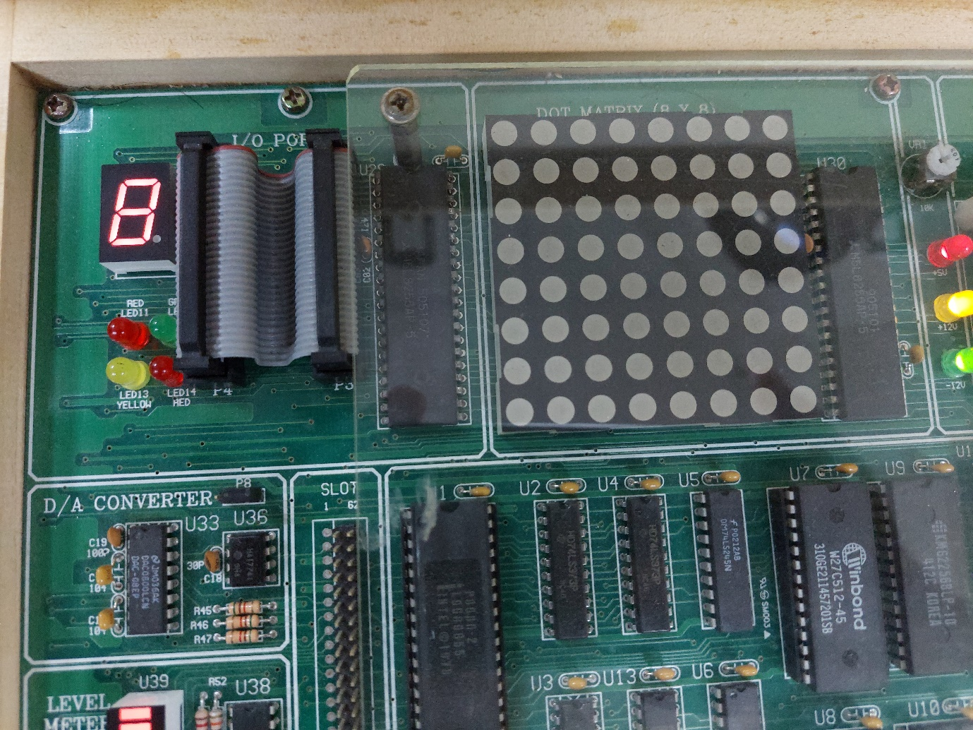

Fig. 7.9: Output

* 1. **Experimental problem no. 02**

**CODE SEGMENT**

**ASSUME CS: CODE, DS: CODE, SS: CODE, ES: CODE**

**ORG 1000H**

**PORTA EQU 19H**

**CONTRL EQU 1FH**

**MOV AL, 10000000B**

**OUT CONTRL, AL**

**MOV AL, 11111001B**

**OUT PORTA, AL**

**CALL DELAY**

**MOV AL, 10000000B**

**OUT PORTA, AL**

**CALL DELAY**

**MOV AL, 11000000B**

**OUT PORTA, AL**

**CALL DELAY**

**MOV AL, 11111001B**

**OUT PORTA, AL**

**CALL DELAY**

**MOV AL, 11111000B**

**OUT PORTA, AL**

**CALL DELAY**

**MOV AL, 11111001B**

**OUT PORTA, AL**

**CALL DEALY**

**DELAY PROC**

**MOV CX, 0FFFFH**

**LOOP1;**

**NOP**

**NOP**

**NOP**

**LOOP LOOP1**

**RET**

**DELAY ENDP**

**CODE ENDS**

**END**

* 1. **Output procedures**

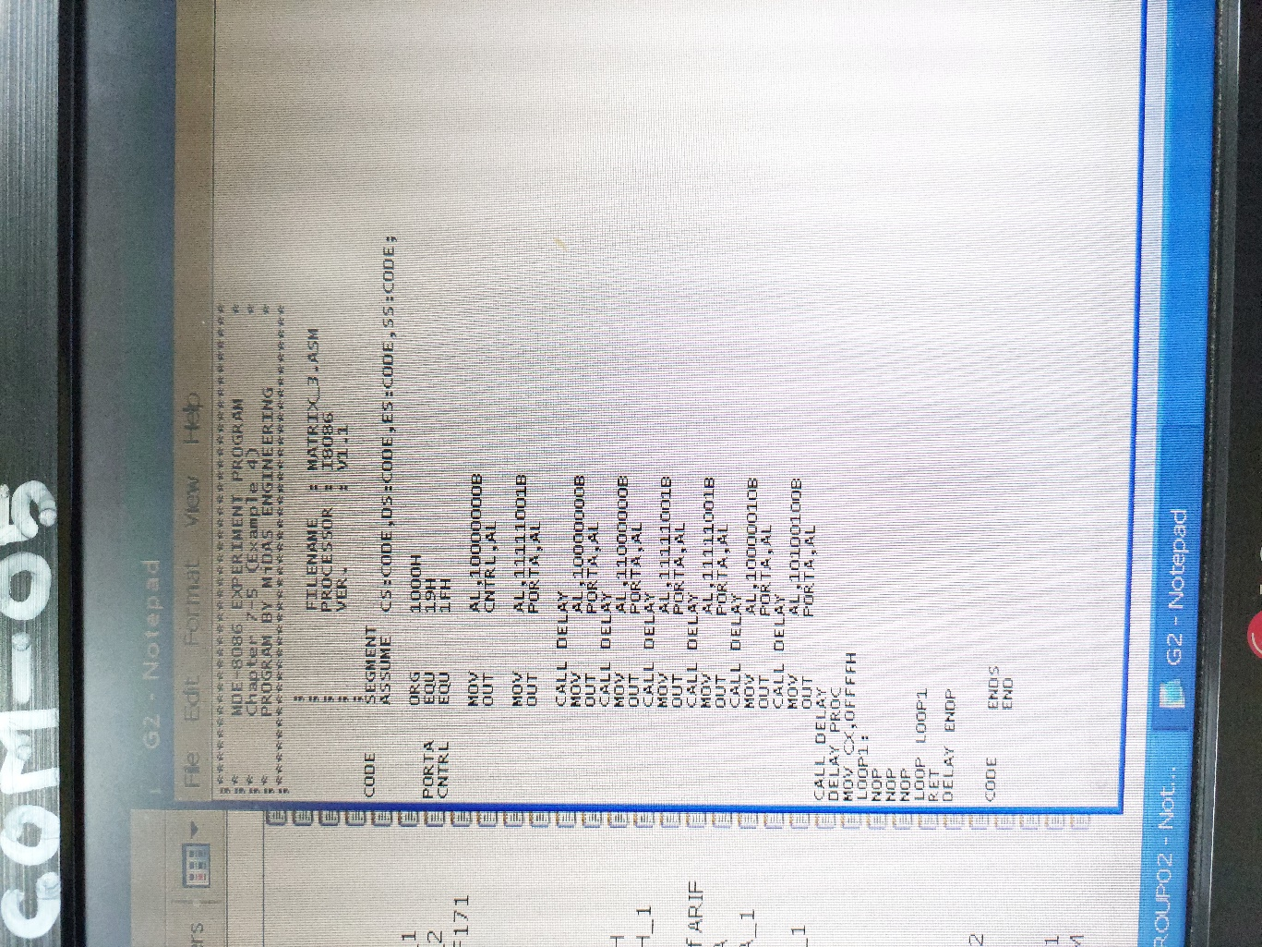

Fig. 7.10: Writing program on notepad

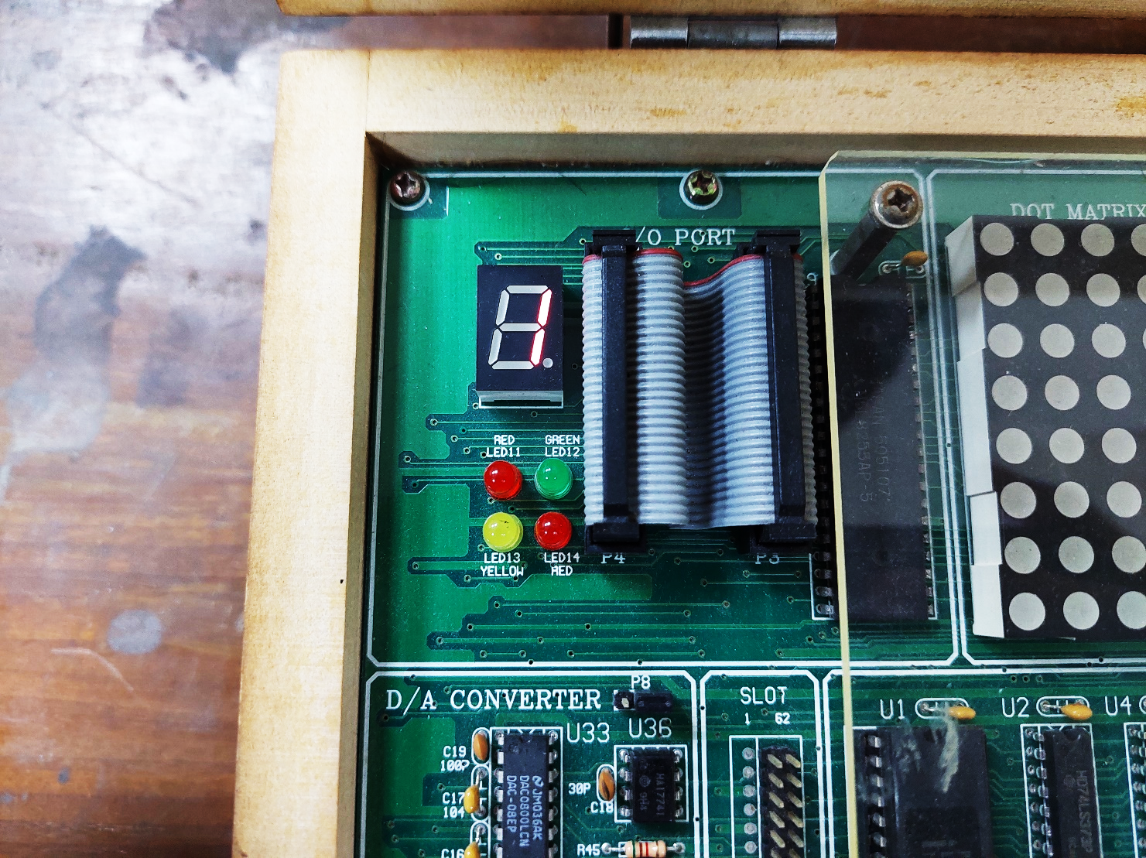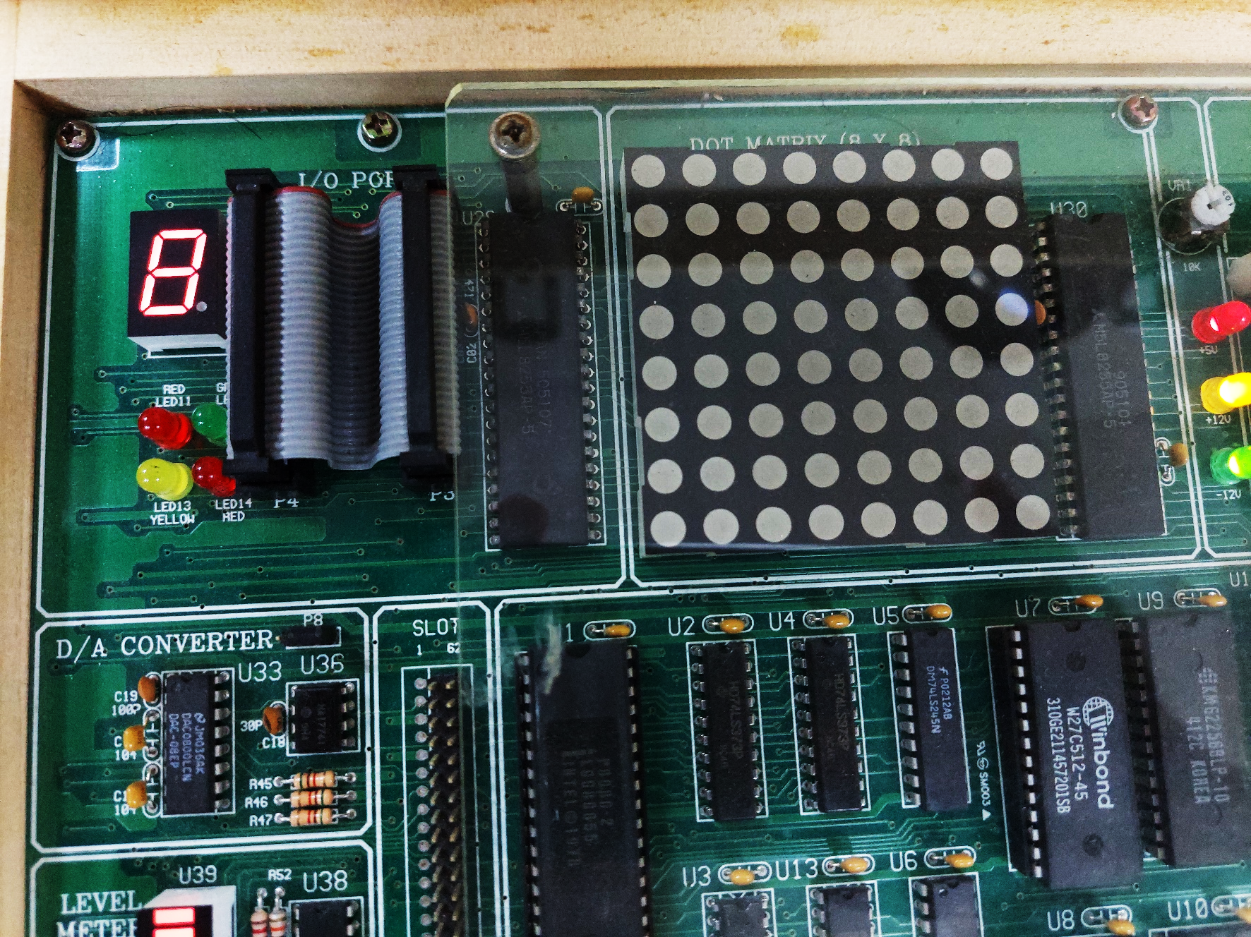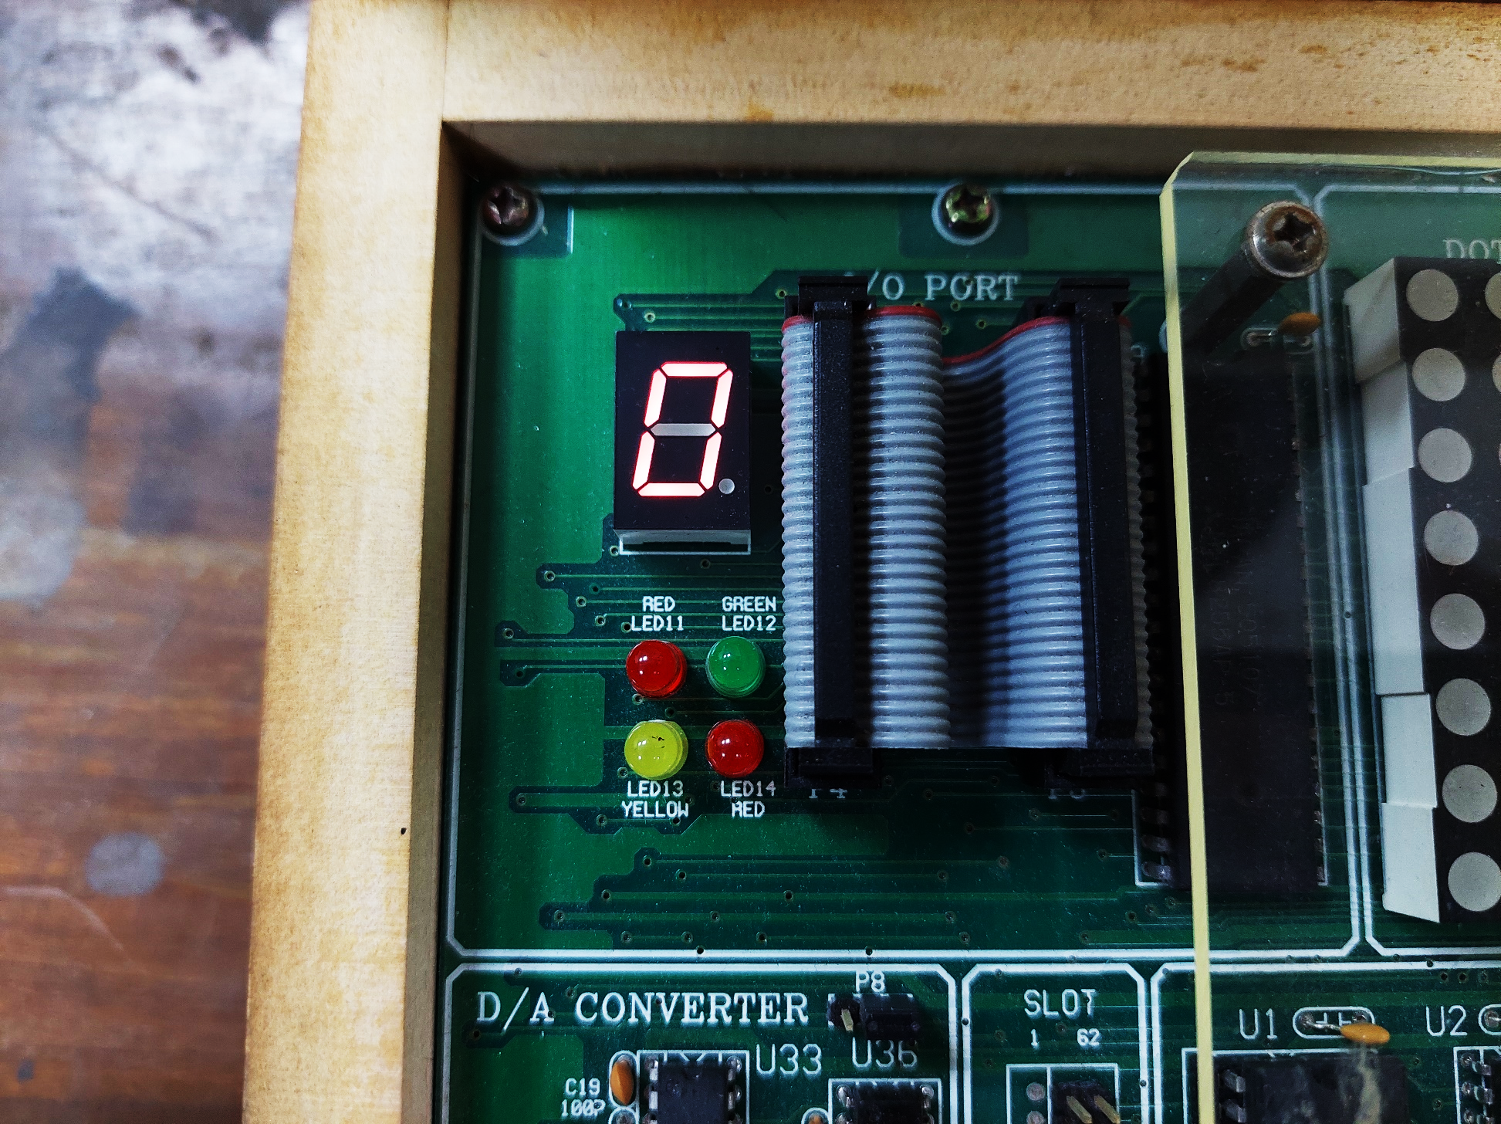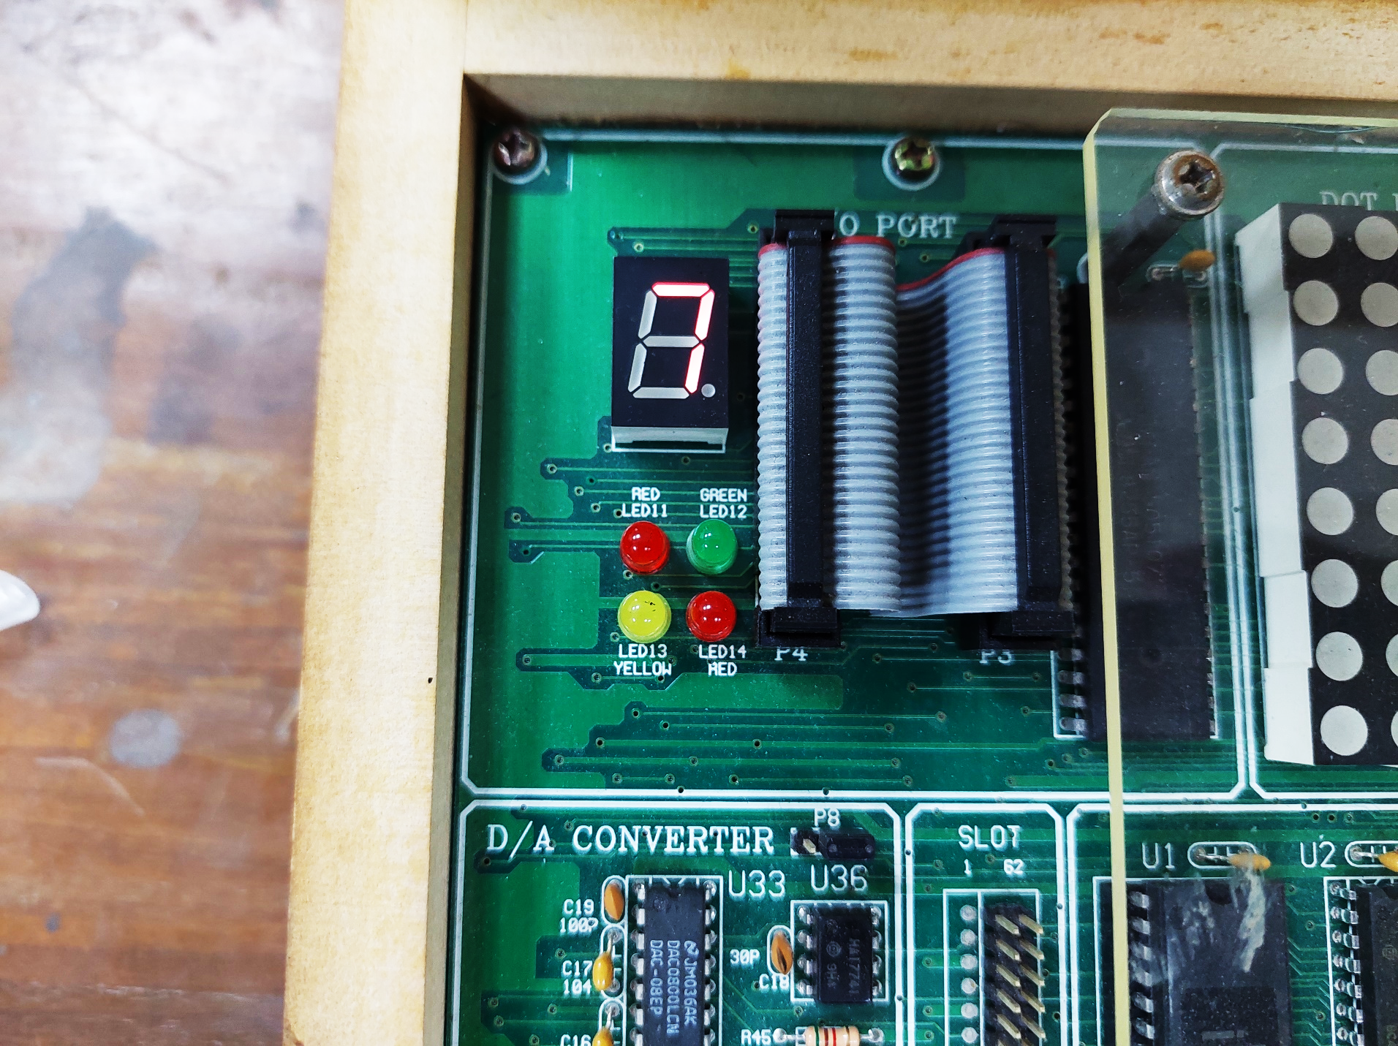

Fig. 7.10: 1801171 as output

* 1. **Discussion & Conclusion**

The procedure of working in serial monitor mode or PC mode with the 8086 MDA kit was introduced in this experiment. In this case, we used the MDA 8086 kit's direct monitor mode. We used code to perform the multiplication of two numbers.

A program was developed in notepad and saved as ‘.**asm**’ file, which was then translated to ‘.**obj**’ using Microsoft Macro Assembler. The ‘.obj’ file was then translated into a ‘.**abs**‘ file using the LOD186 software. The ‘.**abs**’ file was then executed by following the instructions, and the output was observed using both single-step execution and direct execution.